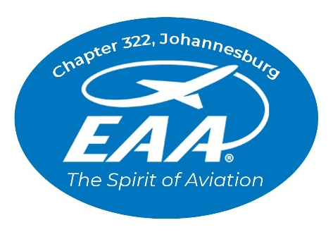

16 March 2026

To whom his may concern,

RE: LETTER OF AUTHORITY AS ARO REPRESENTATION

This letter serves to confirm that Mr Paul Lastrucci is authorised by the EAA 322 Exco to act as the Chapter ARO Representative.

Please do not hesitate to contact me should you have any queries.

Yours sincerely,

Marie Reddy
EAA Chapter 322 Vice Chairperson
0832597691
322@eaa.org.za

