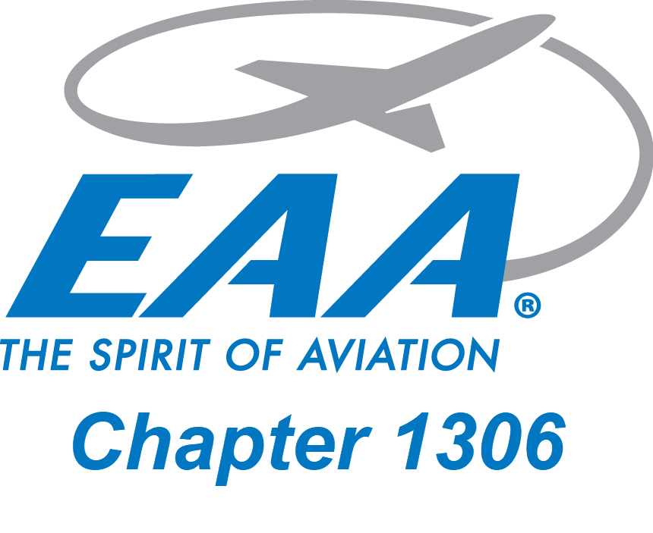
CHAPTER 1502 EAST COAST

Chapter President: Mr.J Van Schalkwyk TEL: 082 322 5722 EMAIL:
Vice President: Mr. R Smith TEL: 083 463 7753 EMAIL: mwrussel@mweb.co.za

1st September 2025
To whom it may concern.

This letter serves as authority for Marie Reddy to act on behalf of EAA Chapter 1502 in all matters pertaining to ARO work.
This authority has been given by myself, in the capacity of secretary of EAA Chapter 1502.

Yours Faithfully.
Alan Lorimer
0837771935.

